Que: create a file "all_scenarios.txt" with given text and use grep or egrep to search match cases:
cat > all_scenarios.txt
Line 1: Hello World! This is a test 12345 and 1234567 apple banana cherry date elephant 1234567890
Line 2: The quick brown fox jumps over the lazy dog 987654321
Line 3: Aaaaa bbbb ccccc ddd eeee fffff gggg hhhh iiiii
Line 4: 123 1234 12345 123456 1234567 12345678
Line 5: Email: john.doe@example.com, jane_smith@company.co.uk, test123@gmail.com
Line 6: Phones: +1-234-567-8901, (555) 123-4567, 987-654-3210
Line 7: Usernames: user1, user_2, user.3, user123, Alice_25
Line 8: Prices: Product A: $12.99, Product B: $45.50, Product C: $199.99
Line 9: IPs: 192.168.1.1, 10.0.0.1, 172.16.254.1
Line 10: Sentences: Hello? How are you? Yes! No, wait... What?
Line 11: Logs: DEBUG INFO ERROR WARNING FATAL
Line 12: Comments: User1: Great! 5 stars. User2: Poor service, very disappointed.
Line 13: Numbers only: 123 456 789 123456 1234567
Line 14: Letters only: apple banana cherry date elephant
Line 15: Mixed: This is a sentence with 123 numbers and many vowels aeiou aeio
Line 16: Credit cards: 4111-1111-1111-1111, 5555-5555-5555-5555
Line 17: Special: Buy 2 get 1 free! Aaa bbb ccc ddd eee fff ggg hhh iiiii
Line 18: The cat sat on the mat. The dog chased the cat.
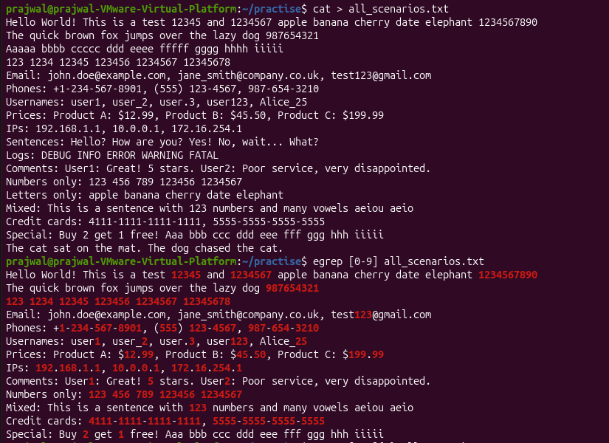

# 1. Find every line that contains at least one digit
# 2. Find every line that contains at least 3 consecutive digits
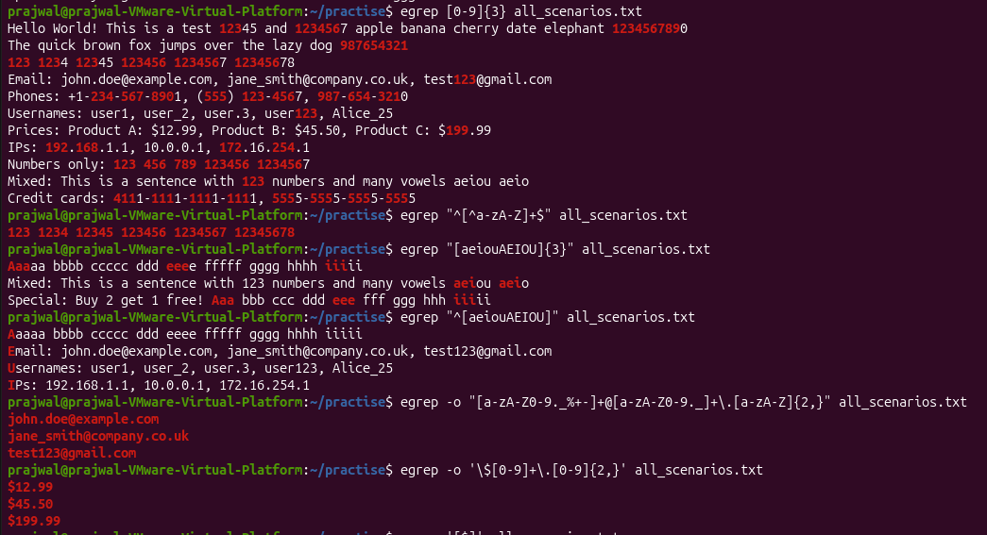
# 3. Find every number-only line (no letters)
# 4. Find every line that contains at least 3 consecutive vowels
# 5. Find every line that starts with a vowel
# 6. Find all email addresses
# 7. Find every price (dollar amount)
# 8. Find every line that contains a dollar sign
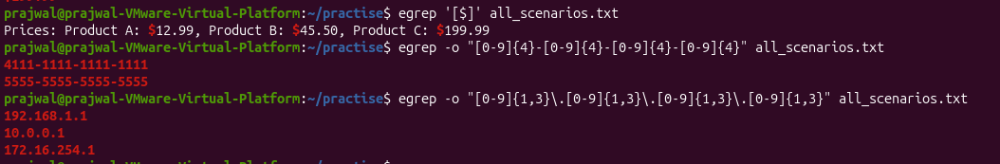
# 9. Find every credit card number
# 10. Find all ipv4 addresses

